With this exercise, have the student see the picture and state, “One Washington, Two Tanks, Three Trains, Four Frogs, etc., and write (or print) the numbers and the words.

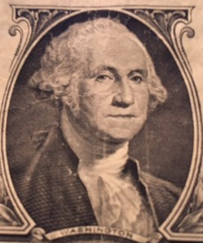

Washington

1 one
__ ____
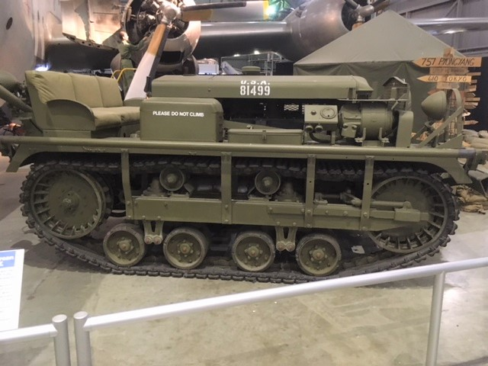

Tanks

2 two
___ _____
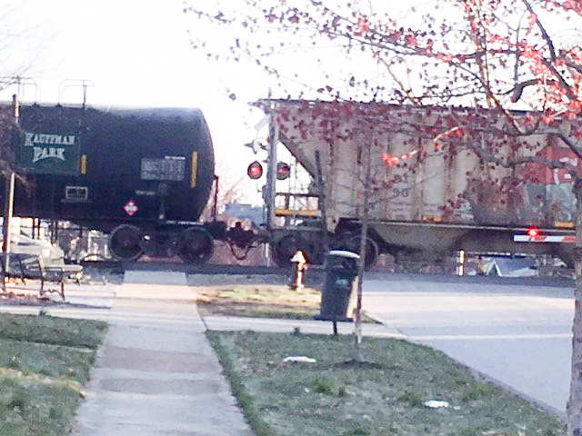

Trains

3 three
___ _____

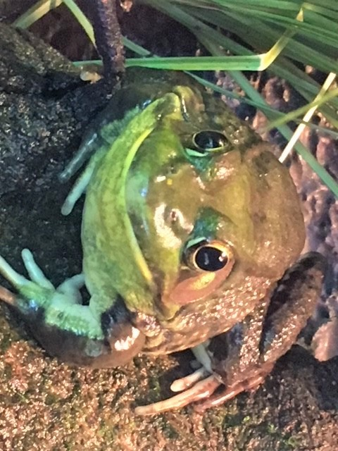

Frogs

4 four
___ _____

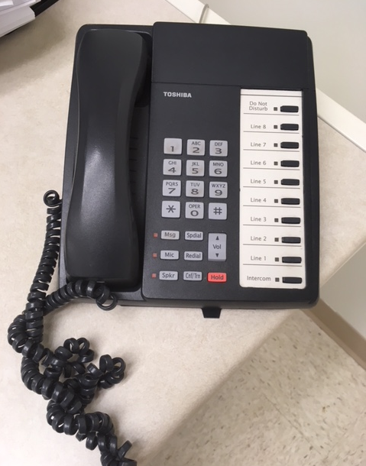

Phones

5 five
___ _____
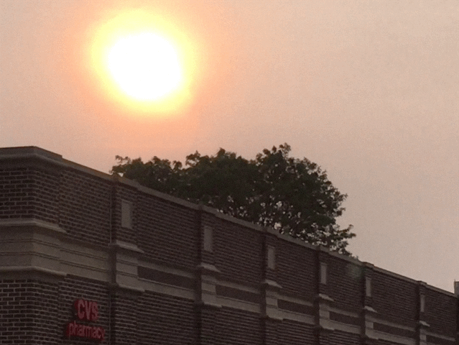

Suns

6 six
___ ______
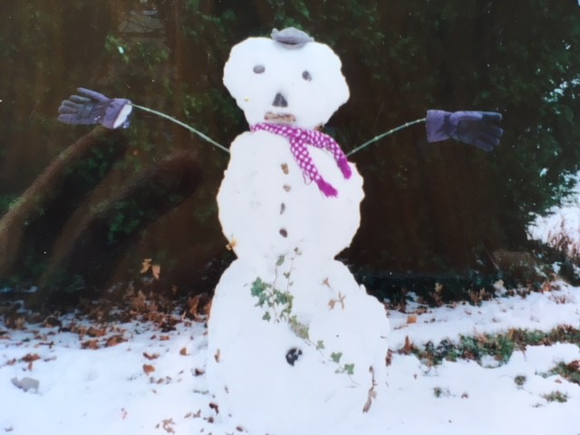

Snowmen

7 seven
__ ______
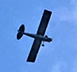
Airplanes

8 eight
___ ______
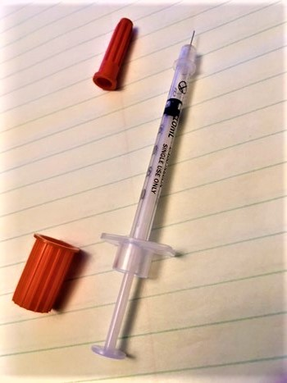

Needles
9 nine
___ ______

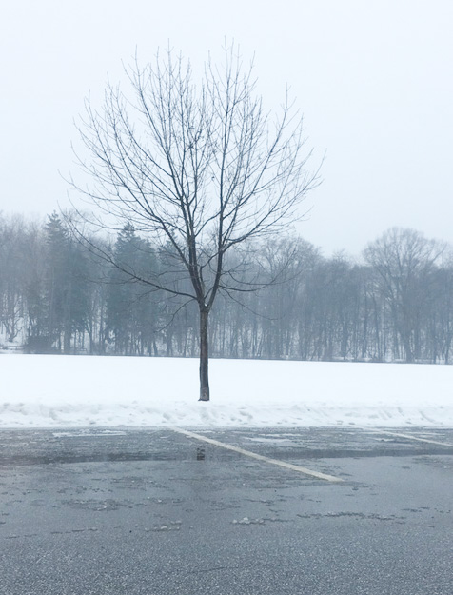
Trees

10 ten
___ _____

